FACULTY -BIODATA
Department | Basic Sciences & Humanities |  |  |  |  |  |  |  |  |  |  |  | 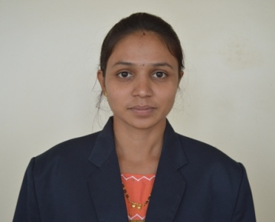
Designation: | Assistant Professor
Name of Faculty: | Prof. Yadav K. V.
Date of Birth: | 20/05/1998 |  |  | Date of Joining: |  |  |  |  | 03/01/2022
Qualification with Class/Grade | UG |  |  | PG |  |  |  |  | Ph.D.
Qualification with Class/Grade | 1ST Class with distinction |  |  | 1ST Class with distinction
Area of Specialization: | Organic Chemistry
Total Experience in Years: | Teaching |  |  |  | Industry |  |  |  |  |  |  | Research
Total Experience in Years: | 04 |  |  |  | - |  |  |  |  |  |  | -
Mobile No: | 9579731395 |  |  |  | E-mail ID: |  |  |  |  |  | kvy_fe@yes.edu.in
Number of PhD, M.Tech , B.Tech Project Guided | UG: |  |  |  |  |  | PG: |  |  |  |  |  | Ph.D. :
Professional Society Memberships | Nil
Paper Published in Journals | National: Nil |  |  |  |  |  |  | International: Nil
Paper Presented in Conferences | National: 01 |  |  |  |  |  |  | International: Nil
Books/Chapters/ Patents / Copy rights Published | Books: - Nil |  | Chapters:- Nil |  |  |  |  | Patents: Nil |  |  |  |  | Copyrights: - Nil
STTPs, FDPs, Workshops attended | STTPs: Nil |  |  |  |  | FDPs: 04 |  |  |  |  |  | Workshops: 02
Webinars & Seminars attended | Webinars: |  |  |  |  |  |  |  |  | Seminars:
STTP, FDP,Webinar & Seminar conducted | STTP: Nil | FDP: Nil |  |  |  |  |  | Seminar: Nil |  |  |  |  | Webinar: Nil
Resource Person Work Details
NPTEL/Swayam/NITTR/MOOC/ Other courses | Completed 2 NPTEL Course on effective teaching and NBA based.
Awards/Recognitions
Consultancy Activities | O
Google Scholar Link
Google Site/Website link | https://sites.google.com/yes.edu.in/prof-yadav-k-v/home


Name & Signature of Faculty

