FACULTY-BIODATA
Department | BASIC SCIENCES & HUMANITIES DEPARTMENT |  |  |  |  |  |  |  |  |  |  | 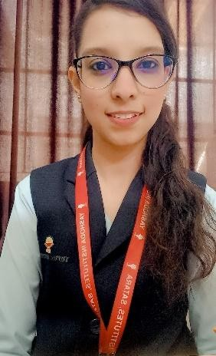
Designation: | ASSISTANT PROFESSOR
Name of Faculty: | Ms. Attar Masira Nisar
Date of Birth: | 02/11/1999 |  | Date of Joining: |  |  | 1/7/2023
Qualification with Class/Grade | UG |  | PG |  |  | Ph.D.
Qualification with Class/Grade | First class with distinction |  | First class with distinction |  |  | PURSUING
Area of Specialization: | M.Sc (Organic Chemistry)
Total Experience in Years: | Teaching |  |  | Industry |  |  |  |  |  |  | Research
Total Experience in Years: | 4 years |  |  | 00 |  |  |  |  |  |  | 4 years
Mobile No: | 8975260976 |  |  | E-mail ID: |  |  |  |  |  | masiraattar_engg@yes.edu.in
Number of PhD, M. Tech , B. Tech Project Guided | UG: 0 |  |  |  |  |  | PG: Nil |  |  |  |  | Ph.D. : Nil
Professional Society Memberships | -
Paper Published in Journals | National: 0 |  |  |  |  |  |  | International: 2
Paper Presented in Conferences | National: 0 |  |  |  |  |  |  | International: 2
Books/Chapters/ Patents / Copy rights Published | Books: 0 |  | Chapters: 0 |  |  |  |  | Patents:- 0 |  |  |  | Copyrights: -0
STTPs, FDPs, Workshops attended | STTPs: 4 |  |  |  | FDPs: 6 |  |  |  |  |  | Workshops: 3
Webinars & Seminars attended | Webinars: 3 |  |  |  |  |  |  |  | Seminars: 4
STTP, FDP,Webinar& Seminar conducted | STTP: 1 | FDP: 0 |  |  |  |  |  | Seminar: 0 |  |  |  | Webinar: 0
Resource Person Work Details
NPTEL/Swayam/NITTR/MOOC/ Other courses | 1.Patent Drafting for Beginers.
Awards/Recognitions | First prize in Conceptual wallpaper activity conducted by YCIS, 2021.
Consultancy | O -
Google Scholar Link | -
Google Site | https://sites.google.com/yes.edu.in/missattarmn/home
 (Ms. Attar Masira N.)

