FACULTY -BIODATA
Department | M.Pharmacy |  |  |  |  |  |  |  |  |  |  | 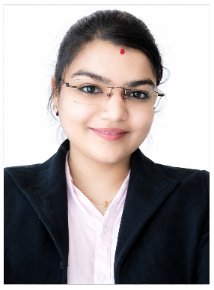
Designation: | Associate professor
Name of Faculty: | Miss.Aishwarya Ramchandra Bhandare
Date of Birth: | 01/06/1996 |  | Date of Joining: |  |  | 18/08/2025
Qualification with Class/Grade | UG |  | PG |  |  | Ph.D.
Qualification with Class/Grade | First Class With Distinction |  | First Class With Distinction
Area of Specialization:
Total Experience in Years: | Teaching |  |  | Industry |  |  |  |  |  |  | Research
Total Experience in Years: | 6 Months |  |  | 6 Years
Mobile No: | 7744943717 |  |  | E-mail ID: |  |  |  |  |  | Aishwaryabhandare_pharm@yes.edu.in
Number of PhD, M.Pharm , B.Pharm Project Guided | UG: |  |  |  |  |  | PG:06 |  |  |  |  | Ph.D. :
Professional Society Memberships
Paper Published in Journals | National: 00 |  |  |  |  |  |  | International: 01
Paper Presented in Conferences | National: 00 |  |  |  |  |  |  | International: 00
Books/Chapters/ Patents / Copy rights Published | Books: |  | Chapters:- |  |  |  |  | Patents: |  |  |  | Copyrights: -
STTPs, FDPs, Workshops attended | STTPs: |  |  |  | FDPs: 00 |  |  |  |  |  | Workshops: 05
Webinars & Seminars attended | Webinars: 02 |  |  |  |  |  |  |  | Seminars: 03
STTP, FDP,Webinar & Seminar conducted | STTP: | FDP: |  |  |  |  |  | Seminar:01 |  |  |  | Webinar:
Resource Person Work Details | Associate professor at Yashoda Technical Campus,Satara.
NPTEL/Swayam/NITTR/MOOC/ Other courses | NA
Awards/Recognitions | NA
Consultancy Activities | NA
Google Scholar Link | https://scholar.google.com/citations?view_op=new_articles&hl=en&imq=aishwarya+ramchandra+bhandare#
Google Site/Website link


Name & Signature of Faculty
Ms. Aishwarya Bhandare

