FACULTY - BIODATA
Department | - Pharm. (Pharmaceutical Chemistry) |  |  |  |  |  |  |  |  |  |  | 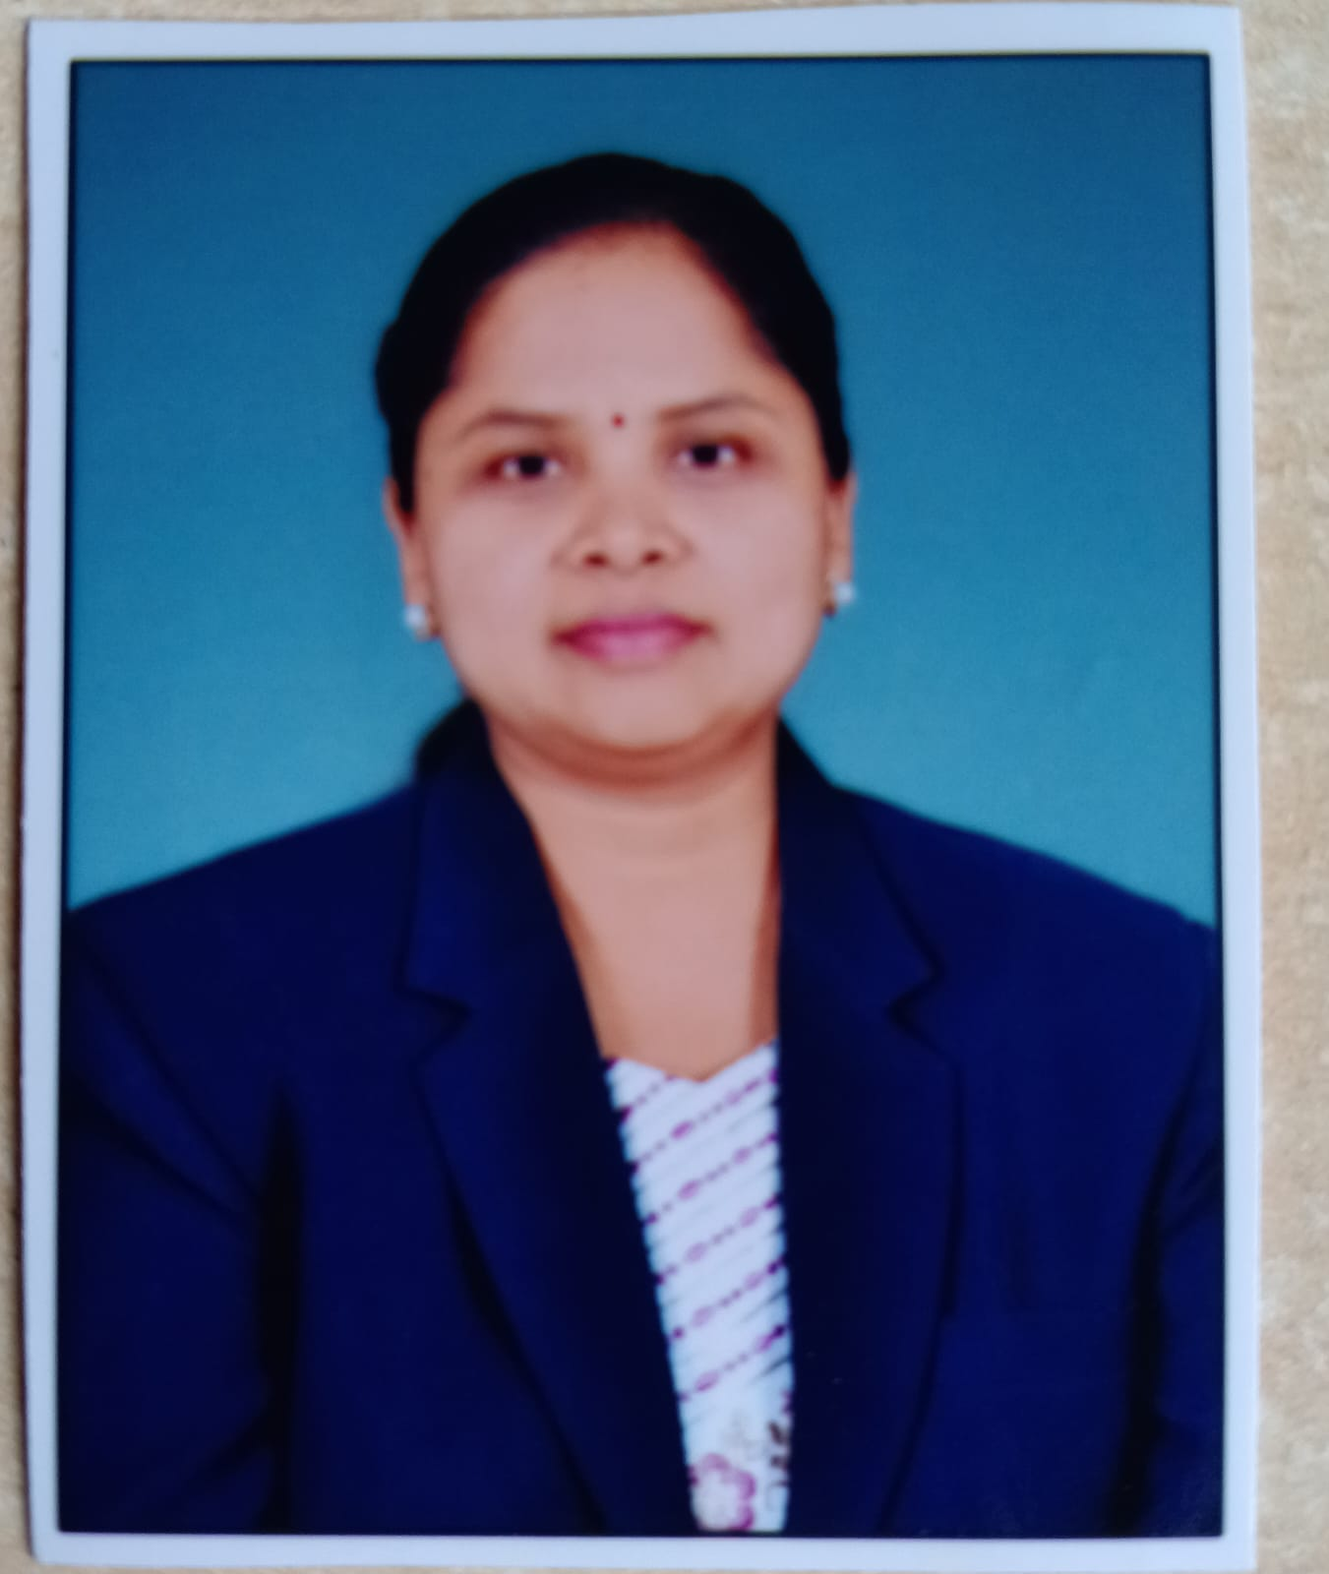
Designation: | Associate Professor
Name of Faculty: | Mrs. Gaikwad Pallavi Sunil
Date of Birth: | 21/01/1982 |  | Date of Joining: |  |  | 01/09/2025
Qualification with Class/Grade | UG |  | PG |  |  | Ph.D.
Qualification with Class/Grade | 63.17% |  | 61.73% |  |  | Pursuing from Shivaji University
Area of Specialization: | Pharmaceutics
Total Experience in Years: | Teaching |  |  | Industry |  |  |  |  |  |  | Research
Total Experience in Years: | 17 |  |  | 1 |  |  |  |  |  |  | 3
Mobile No: | 9890306817 |  |  | E-mail ID: |  |  |  |  |  | pallavigaikwad_pharm@yes.edu.in
Number of PhD, M.Pharm , B.Pharm Project Guided | UG:10 |  |  |  |  |  | PG: 4 |  |  |  |  | Ph.D. : 0
Professional Society Memberships | Pharmacy Council of India,  Association of Pharmaceutical Teachers of India
Paper Published in Journals | National: 19 |  |  |  |  |  |  | International: 5
Paper Presented in Conferences | National: 1 |  |  |  |  |  |  | International: 2
Books/Chapters/ Patents / Copy rights Published | Books: -- |  | Chapters: -- |  |  |  |  | Patents: 3 |  |  |  | Copyrights: --
STTPs, FDPs, Workshops attended | STTPs: -- |  |  |  | FDPs: 5 |  |  |  |  |  | Workshops: 4
Webinars & Seminars attended | Webinars: 2 |  |  |  |  |  |  |  | Seminars: 1
STTP, FDP,Webinar & Seminar conducted | STTP: -- | FDP: -- |  |  |  |  |  | Seminar: 1 |  |  |  | Webinar: 1
Resource Person Work Details | Guest speaker at Shri Santkrupa College of Pharmacy, Ghogaon, Karad (March 2024)  Guest speaker at Ararsh College of Pharmacy, Vita, Sangli (March 2023)  Guest speaker at Govt. College of Pharmacy, Karad (March 2022)  Guest speaker at Amdar Shashikant Shinde Mahavidyalay Medha (December 2021)
NPTEL/Swayam/NITTR/MOOC/ Other courses | NA
Awards/Recognitions | NA
Consultancy Activities | NA
Google Scholar Link | https://scholar.google.com/scholar?q=pallavi+salve&hl=en&as_sdt=0,5
Google Site/Website link


Name & Signature of Faculty

