FACULTY - BIODATA
Department | B. Pharmacy |  |  |  |  |  |  |  |  |  |  | 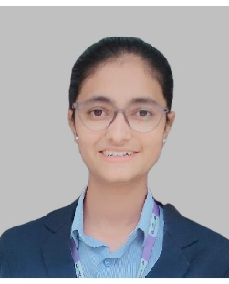
Designation: | Assistant Professor
Name of Faculty: | Miss. Momin Saniya Javed
Date of Birth: | 14/02/2002 |  | Date of Joining: |  |  | 18/08/2025
Qualification with Class/Grade | UG |  | PG |  |  | Ph.D.
Qualification with Class/Grade | 85.26% |  |  |  |  | -
Area of Specialization: | Pharmaceutical chemistry
Total Experience in Years: | Teaching |  |  | Industry |  |  |  |  |  |  | Research
Total Experience in Years: | 0 |  |  | 0 |  |  |  |  |  |  | 0
Mobile No: | 8888535502 |  |  | E-mail ID: |  |  |  |  |  | saniyamomin_pharm@yes.edu.in
Number of PhD, M.Pharm , B.Pharm Project Guided | UG: 0 |  |  |  |  |  | PG: 0 |  |  |  |  | Ph.D.:0
Professional Society Memberships | Pharmacy Council of India
Paper Published in Journals | National: 0 |  |  |  |  |  |  | International: 4
Paper Presented in Conferences | National: 0 |  |  |  |  |  |  | International: 0
Books/Chapters/ Patents / Copy rights Published | Books: |  | Chapters:- |  |  |  |  | Patents: |  |  |  | Copyrights: -1
STTPs, FDPs, Workshops attended | STTPs: |  |  |  | FDPs: |  |  |  |  |  | Workshops:
Webinars & Seminars attended | Webinars: 1 |  |  |  |  |  |  |  | Seminars: 1
STTP, FDP,Webinar & Seminar conducted | STTP: | FDP: |  |  |  |  |  | Seminar: |  |  |  | Webinar:
Resource Person Work Details | Assistant Prof. at YSPMS Yashoda Technical Campus
NPTEL/Swayam/NITTR/MOOC/ Other courses | NA
Awards/Recognitions | NA
Consultancy Activities | NA
Google Scholar Link | https://scholar.google.com/citations?hl=en&user=jUzsZYYAAAAJ
Google Site/Website link

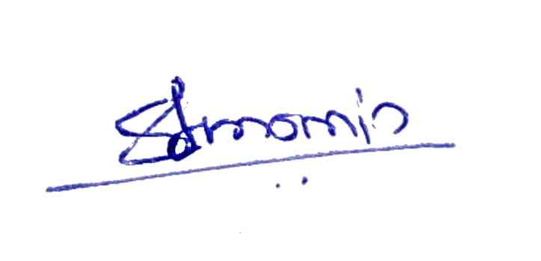
Saniya Javed Momin
Name & Signature of Faculty

