FACULTY-BIODATA
Department | B. Pharmacy |  |  |  |  |  |  |  |  |  |  | 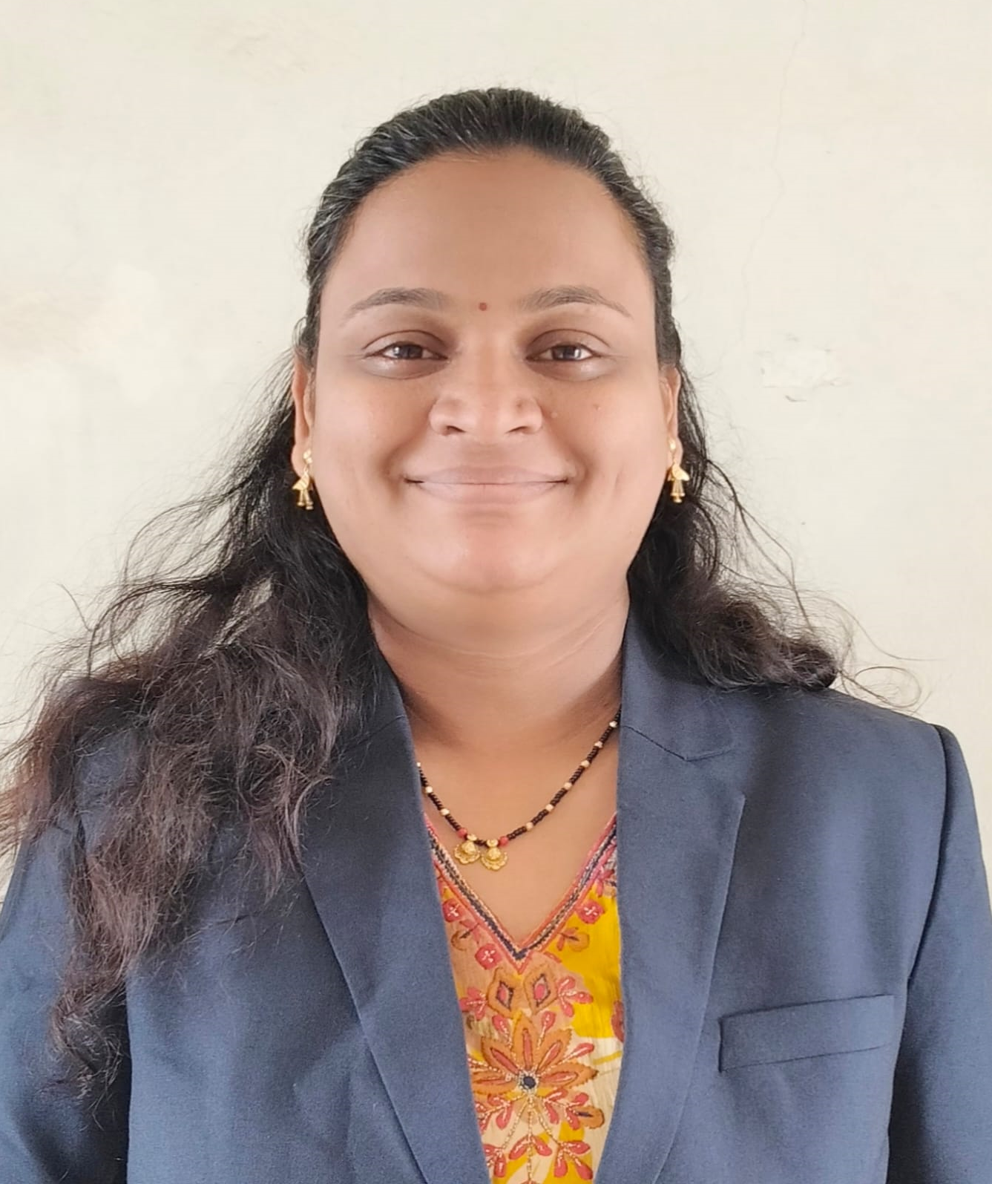
Designation: | Lecturer
Name of Faculty: | Mrs. Shital Siddharth Gole
Date of Birth: | 26/03/1986 |  | Date of Joining: |  |  | 01/07/2025
Qualification with Class/Grade | UG |  | PG |  |  | Ph.D.
Qualification with Class/Grade | Ist Class |  | Persuing
Area of Specialization: | Pharmacognosy
Total Experience in Years: | Teaching |  |  | Industry |  |  |  |  |  |  | Research
Total Experience in Years: | 11 |  |  | - |  |  |  |  |  |  | -
Mobile No: | 9850852628 |  |  | E-mail ID: |  |  |  |  |  | shitalgole_pharm@yes.edu.in
Number of PhD, M.Pharm , B.Pharm Project Guided | UG: 0 |  |  |  |  |  | PG: 0 |  |  |  |  | Ph.D.:0
Professional Society Memberships | Pharmacy Council of India
Paper Published in Journals | National: 1 |  |  |  |  |  |  | International: 1
Paper Presented in Conferences | National: 1 |  |  |  |  |  |  | International: 0
Books/Chapters/ Patents / Copy rights Published | Books: 1 |  | Chapters:- |  |  |  |  | Patents: |  |  |  | Copyrights: -
STTPs, FDPs, Workshops attended | STTPs: |  |  |  | FDPs: 3 |  |  |  |  |  | Workshops: 1
Webinars & Seminars attended | Webinars: 1 |  |  |  |  |  |  |  | Seminars:
STTP, FDP,Webinar & Seminar conducted | STTP: | FDP: |  |  |  |  |  | Seminar: |  |  |  | Webinar:
Resource Person Work Details | Lecturer at YSPMS Yashoda Technical Campus
NPTEL/Swayam/NITTR/MOOC/ Other courses | NA
Awards/Recognitions | NA
Consultancy Activities | NA
Google Scholar Link | https://scholar.google.com/citations?hl=en&user=-
Google Site/Website link

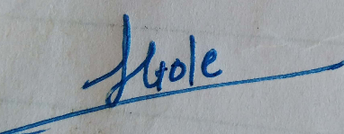

(Mrs. Shital Siddharth Gole)
Name & Signature of Faculty

