Yashoda Shikshan Prasarak Mandal’s
Yashoda Technical Campus, Satara.


FACULTY -BIODATA

Department | Civil Polytechnic |  |  |  |  |  |  |  | 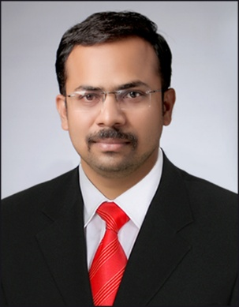
Designation: | Lecturer
Name of Faculty: | Mr. Deshmukh Narendra Shivajirao
Date of Birth: | 13/06/1993 | Date of Joining: |  | 14 July 2025
Qualification with Class/Grade | UG | PG |  | Ph.D.
Qualification with Class/Grade | First Class | Appearing |  | ----
Area of Specialization: | Construction & Management
Total Experience in Years: | Teaching |  | Industry |  |  |  |  | Research
Total Experience in Years: | 10 |  | ---
Mobile No: | 7304013693 |  | E-mail ID: |  |  |  | deshmukhnarendra19@gmail.com
Number of PhD, M.Tech , B.Tech Project Guided | UG: |  |  |  | PG: |  |  |  | Ph.D. :
Professional Society
Memberships
Paper Published in  Journals | National: |  |  |  | International: 04
Paper Presented in  Conferences | National: |  |  |  | International:
Books/Chapters/ Patents /  Copy rights Published | Books: - | Chapters: - |  |  | Patents: |  |  |  | Copyrights: -
STTPs, FDPs, Workshops  attended | STTPs: |  | FDPs: 06 |  |  |  |  | Workshops: 04
Webinars & Seminars  attended | Webinars: |  |  |  |  | Seminars: 02
STTP, FDP,Webinar&  Seminar conducted | STTP: - | FDP:- |  |  | Seminar:- |  |  |  | Webinar: -
Resource Person Work Details
NPTEL/Swayam/NITTR/ MOOC/ Other courses | 01
Awards/Recognitions
Consultancy Activities
Google Scholar Link
Google Site/Website link

