FACULTY-BIODATA
Department | CIVIL |  |  |  |  |  |  |  |  |  |  | 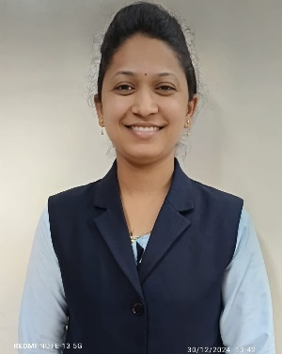
Designation: | LECTURER
Name of Faculty: | Mrs. PALLAVI KETAN JADHAV
Date of Birth: | 22/05/1992 | Date of Joining: |  |  |  | 5/07/2024
Qualification with Class/Grade | UG | PG |  |  |  | Ph.D.
Qualification with Class/Grade | 1 st Class | 1 st Class |  |  |  | -
Area of Specialization: | CIVIL ENGINEERING
Total Experience in Years: | Teaching |  |  | Industry |  |  |  |  |  |  | Research
Total Experience in Years: | 06 |  |  | - |  |  |  |  |  |  | -
Mobile No: | 8600385772 |  |  | E-mail ID: |  |  |  |  |  | Pallavikashid92@gmail.com
Number of PhD, M. Tech , B. Tech Project Guided | UG: - |  |  |  |  |  | PG: - |  |  |  |  | Ph.D.: -
Professional Society Memberships | -
Paper Published in Journals | National: - |  |  |  |  |  |  | International: -2
Paper Presented in Conferences | National: - |  |  |  |  |  |  | International: -
Books/Chapters/ Patents / Copy rights Published | Books: - | Chapters:- |  |  |  |  |  | Patents: - |  |  |  | Copyrights: -
STTPs, FDPs, Workshops attended | STTPs: - |  |  |  | FDPs: 2 |  |  |  |  |  | Workshops: -
Webinars & Seminars attended | Webinars: - |  |  |  |  |  |  |  | Seminars: -
STTP, FDP, Webinar& Seminar conducted | STTP: - |  | FDP: - |  |  |  |  | Seminar: - |  |  |  | Webinar: -
Resource Person Work Details | -
NPTEL/Swayam/NITTR/MOOC/ Other courses | 1
Awards/Recognitions | -
Consultancy Activities | O -
Google Scholar Link | -
Google Site/Website link | -

(Mrs. Pallavi Ketan Jadhav)
Name & Signature of Faculty

