FACULTY -BIODATA
Department | B. Pharmacy |  |  |  |  |  |  |  |  |  |  | 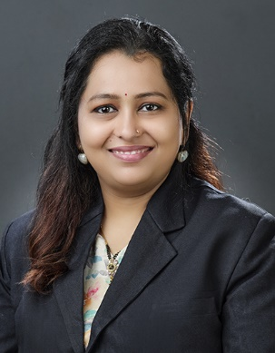
Designation: | Assistant professor
Name of Faculty: | Dr. Swapnali Vishal Suryavanshi.
Date of Birth: | 03/11/1987 | Date of Joining: |  |  |  | 11/06/2016
Qualification with Class/Grade | UG | PG |  |  |  | Ph.D.
Qualification with Class/Grade | Second Class | First Class |  |  |  | Completeed
Area of Specialization: | Pharmaceutics
Total Experience in Years: | Teaching |  |  | Industry |  |  |  |  |  |  | Research
Total Experience in Years: | 09 |  |  | - |  |  |  |  |  |  | -
Mobile No: | 8379977299 |  |  | E-mail ID: |  |  |  |  |  | sdp_dpharm@yes.edu.in
Number of PhD, M.Tech , B.Tech Project Guided | UG: - |  |  |  |  |  | PG: - |  |  |  |  | Ph.D. : -
Professional Society Memberships | -
Paper Published in Journals | National: 08 |  |  |  |  |  |  | International: 06
Paper Presented in Conferences | National: - 01 |  |  |  |  |  |  | International: - -
Books/Chapters/ Patents / Copy rights Published | Books: - 03 | Chapters:- - |  |  |  |  |  | Patents: 04 |  |  |  | Copyrights: -
STTPs, FDPs, Workshops attended | STTPs: |  |  |  | FDPs: 8 |  |  |  |  |  | Workshops: 6
Webinars & Seminars attended | Webinars: 5 |  |  |  |  |  |  |  | Seminars: - 02
STTP, FDP,Webinar& Seminar conducted | STTP: - |  | FDP: - 5 |  |  |  |  | Seminar: - |  |  |  | Webinar: -
Resource Person Work Details | -----------
NPTEL/Swayam/NITTR/MOOC/ Other courses | 01
Awards/Recognitions | ----------
Consultancy Activities | O -----------
Google Scholar Link | -----------
Google Site/Website link | -----------

