FACULTY -BIODATA
Department | D.Pharmacy |  |  |  |  |  |  |  |  |  |  | 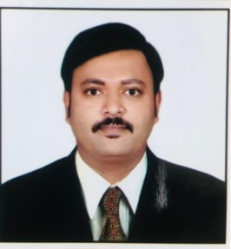
Designation: | Lecturer
Name of Faculty: | Mr. Bhongale Ashish Sanjay
Date of Birth: | 24/01/1991 | Date of Joining: |  |  |  | 01/12/2021
Qualification with Class/Grade | UG | PG |  |  |  | Ph.D.
 | First Class | First Class |  |  |  | Registered
Area of Specialization: | Pharmaceutics
Total Experience in Years: | Teaching |  |  | Industry |  |  |  |  |  |  | Research
 | 7.3 |  |  | - |  |  |  |  |  |  | -
Mobile No: | 8975809500 |  |  | E-mail ID: |  |  |  |  |  | asb_dpharm@yes.edu.in
Number of PhD, M.Tech , B.Tech Project Guided | UG: - |  |  |  |  |  | PG: 05 |  |  |  |  | Ph.D. : -
Professional Society Memberships | -
Paper Published in Journals | National: 10 |  |  |  |  |  |  | International: 06
Paper Presented in Conferences | National: 01 |  |  |  |  |  |  | International: -
Books/Chapters/ Patents / Copy rights Published | Books: - | Chapters:- |  |  |  |  |  | Patents: 06 |  |  |  | Copyrights: -
STTPs, FDPs, Workshops attended | STTPs: |  |  |  | FDPs: 20 |  |  |  |  |  | Workshops: 9
Webinars & Seminars attended | Webinars: 7 |  |  |  |  |  |  |  | Seminars: -
STTP, FDP,Webinar& Seminar conducted | STTP: - |  | FDP: 02 |  |  |  |  | Seminar: 22 |  |  |  | Webinar: 03
Resource Person Work Details
NPTEL/Swayam/NITTR/MOOC/ Other courses | -
Awards/Recognitions | -
Consultancy Activities | O -
Google Scholar Link | -
Google Site/Website link | -

Name & Signature of Faculty
Mr.Bhongale A.S.

