FACULTY -BIODATA
Department | Electronics & Telecommunication Engineering |  |  |  |  |  |  |  |  |  |  | 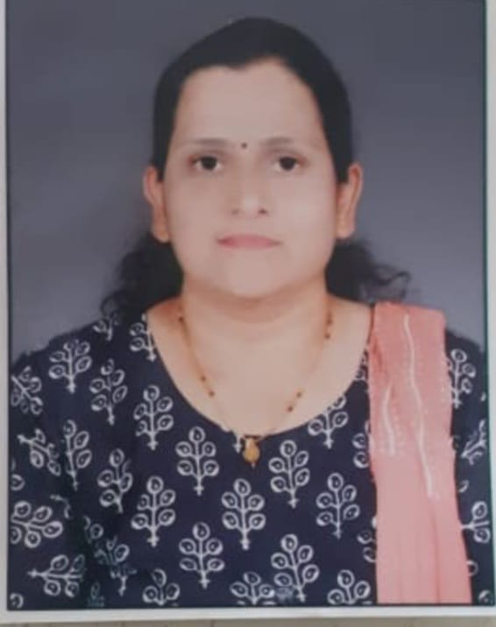
Designation: | Assistant Professor
Name of Faculty: | Mrs.Nikam Rupali Atul
Date of Birth: | 02/07/1982 |  | Date of Joining: |  |  |  |  | 08/05/2025
Qualification with Class/Grade | UG |  | PG |  |  |  |  | Ph.D.
 | Electronics & Telecommunication Engg. First Class |  | Electronics Engg. First Class |  |  |  |  | .
Area of Specialization: | Wireless Communication.
Total Experience in Years: | Teaching |  |  | Industry |  |  |  |  |  |  | Research
 | 0 |  |  | 0 |  |  |  |  |  |  | 1.5
Mobile No: | 8421512099 |  |  | E-mail ID: |  |  |  |  |  | salunkhe.rupali@gmail.com
Number of PhD, M.Tech , B.Tech Project Guided | UG: 0 |  |  |  |  | PG:- |  |  |  |  |  | Ph.D. :-
Professional Society Memberships
Paper Published in Journals | National: 01 |  |  |  |  |  | International: 02
Paper Presented in Conferences | National: 0 |  |  |  |  |  | International: 0
Books/Chapters/ Patents / Copy rights Published | Books: -0 |  | Chapters: - |  |  |  | Patents: 01 |  |  |  |  | Copyrights: -0
STTPs, FDPs, Workshops attended | STTPs: |  |  |  | FDPs: 04 |  |  |  |  |  | Workshops: 2
Webinars & Seminars attended | Webinars: 04 |  |  |  |  |  |  |  | Seminars: 0
STTP, FDP,Webinar& Seminar conducted | STTP: 0 | FDP:0 |  |  |  |  | Seminar:0 |  |  |  |  | Webinar:
Resource Person Work Details
NPTEL/Swayam/NITTR/ MOOC/ Other courses
Awards/Recognitions
Consultancy Activities | O -
Google Scholar Link
Google Site/Website link

Name & Signature of Faculty
Mrs.Nikam R.A.

