FACULTY -BIODATA
Department | Electronics & Telecommunication Engineering |  |  |  |  |  |  |  |  |  |  | 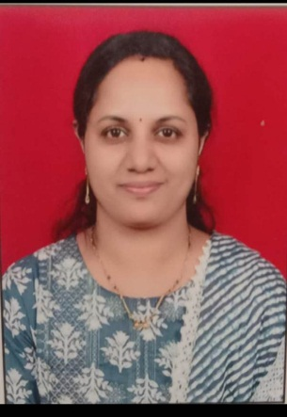
Designation: | Assistant Professor
Name of Faculty: | Mrs.Sandhya Sandeep Nalage
Date of Birth: | 23/06/1984 |  | Date of Joining: |  |  |  |  | 01/03/2025
Qualification with Class/Grade | UG |  | PG |  |  |  |  | Ph.D.
 | Electronics Engg. First Class |  | Electronics Engg. Distinction |  |  |  |  | .
Area of Specialization: | VLSI Design
Total Experience in Years: | Teaching |  |  | Industry |  |  |  |  |  |  | Research
 | 3.5 |  |  | 1.5
Mobile No: | 9922948572 |  |  | E-mail ID: |  |  |  |  |  | sandhyanalage84@gmail.com
Number of PhD, M.Tech , B.Tech Project Guided | UG: 06 |  |  |  |  | PG:- |  |  |  |  |  | Ph.D. :-
Professional Society Memberships
Paper Published in Journals | National: 02 |  |  |  |  |  | International: 0
Paper Presented in Conferences | National: 0 |  |  |  |  |  | International: 0
Books/Chapters/ Patents / Copy rights Published | Books: -0 |  | Chapters: - |  |  |  | Patents: 0 |  |  |  |  | Copyrights: -0
STTPs, FDPs, Workshops attended | STTPs: |  |  |  | FDPs: 0 |  |  |  |  |  | Workshops:
Webinars & Seminars attended | Webinars: 0 |  |  |  |  |  |  |  | Seminars: 0
STTP, FDP,Webinar& Seminar conducted | STTP: 0 | FDP:0 |  |  |  |  | Seminar:0 |  |  |  |  | Webinar:
Resource Person Work Details
NPTEL/Swayam/NITTR/ MOOC/ Other courses
Awards/Recognitions
Consultancy Activities | O -
Google Scholar Link
Google Site/Website link

Name & Signature of Faculty
Mrs.Nalage S.S.

