FACULTY -BIODATA
Department | Electrical Engineering |  |  |  |  |  |  |  |  |  |  |  | 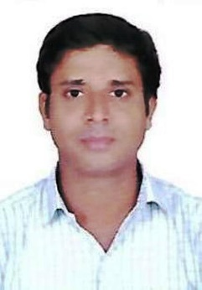
Designation: | Lecturer
Name of Faculty: | Mr. Surendra D. Kadam
Date of Birth: | 6th April, 1983 |  |  | Date of Joining: |  |  |  |  |  | 02.07.2024
Qualification with Class/Grade | UG |  |  | PG |  |  |  |  |  | Ph.D.
 | 60.23  (First Class) |  |  | Pursuing
Area of Specialization: | Electrical Power System
Total Experience in Years: | Teaching |  |  |  | Industry |  |  |  |  |  |  | Research
 | 14 |  |  |  | 1 |  |  |  |  |  |  | -
Mobile No: | +91 8888739156 |  |  |  | E-mail ID: |  |  |  |  |  | surendrakadam_poly@yes.edu.in
Number of PhD, M.Tech , B.Tech Project Guided | UG: 02 |  |  |  |  |  | PG:- |  |  |  |  |  | Ph.D. :-
Professional Society Memberships | -
Paper Published in Journals | National: - |  |  |  |  |  |  | International:
Paper Presented in Conferences | National: - |  |  |  |  |  |  | International: -
Books/Chapters/ Patents / Copy rights Published | Books: - | Chapters:- |  |  |  |  |  | Patents: |  |  |  |  | Copyrights: -
STTPs, FDPs, Workshops attended | STTPs: 02 |  |  |  |  | FDPs: 02 |  |  |  |  |  | Workshops: --01
Webinars & Seminars attended | Webinars: 01 |  |  |  |  |  |  |  | Seminars: --02
STTP, FDP, Webinar & Seminar conducted | STTP: -- |  | FDP: -- |  |  |  |  | Seminar: -- |  |  |  |  | Webinar: 00
Resource Person Work Details | -
NPTEL/Swayam/NITTR/MOOC/ Other courses | -
Awards/Recognitions | -
Consultancy Activities | -
Google Scholar Link
Google Site/Website link | -

Mr. Surendra D. Kadam
Name & Signature of Faculty

