FACULTY -BIODATA
Department | Electrical Engineering |  |  |  |  |  |  |  |  |  |  |  | 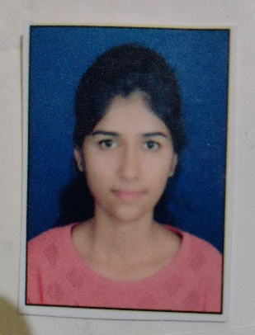
Designation: | Lecturer
Name of Faculty: | Ms. Vibhakti Virsen Gaikwad
Date of Birth: | 11th July, 1995 |  |  | Date of Joining: |  |  |  |  |  | 29.07.2024
Qualification with Class/Grade | UG |  |  | PG |  |  |  |  |  | Ph.D.
70
(First Class with Distinction)
Area of Specialization: | Control Systems
Total Experience in Years: | Teaching |  |  |  | Industry |  |  |  |  |  |  | Research
 | 00 |  |  |  | 2 |  |  |  |  |  |  | -
Mobile No: | +91 9356896674 |  |  |  | E-mail ID: |  |  |  |  |  | vibhaktigaikwad_poly@yes.edu.in  vibhaktigaikwad11@gmail.com
Number of PhD, M.Tech , B.Tech Project Guided | UG: 0 |  |  |  |  |  | PG:-0 |  |  |  |  |  | Ph.D. :-0
Professional Society Memberships | -
Paper Published in Journals | National: - |  |  |  |  |  |  | International: 04
Paper Presented in Conferences | National: - |  |  |  |  |  |  | International: -
Books/Chapters/ Patents / Copy rights Published | Books: - | Chapters:- |  |  |  |  |  | Patents: 01 |  |  |  |  | Copyrights: -
STTPs, FDPs, Workshops attended | STTPs: 04 |  |  |  |  | FDPs: 08 |  |  |  |  |  | Workshops: --01
Webinars & Seminars attended | Webinars: 01 |  |  |  |  |  |  |  | Seminars: --01
STTP, FDP, Webinar & Seminar conducted | STTP: -- |  | FDP: -- |  |  |  |  | Seminar: -- |  |  |  |  | Webinar:
Resource Person Work Details | -
NPTEL/Swayam/NITTR/MOOC/ Other courses | -00
Awards/Recognitions | -
Consultancy Activities | O -
Google Scholar Link
Google Site/Website link | -

Ms. Vibhakti Virsen Gaikwad
Name & Signature of Faculty

